Navigating the Website Menu
On
Phones/Small Tablets
If you are not viewing this web page on a television, desktop, laptop, or larger portable tablet, the organization of the web page may be different on a smaller tablet or phone screen display.
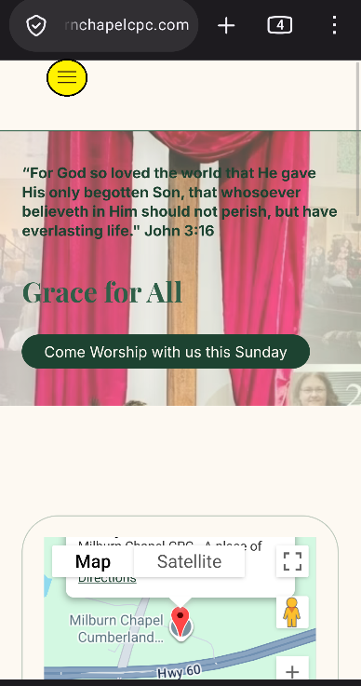
If you are viewing this website on a phone or small tablet, you may see three (3) horizontal lines on the top of the display (see highlighted (yellow) oval).
This is known in the digital world as a “hamburger menu” icon. Its function is to toggle a menu or navigation bar between being collapsed behind the button or displayed on the screen.
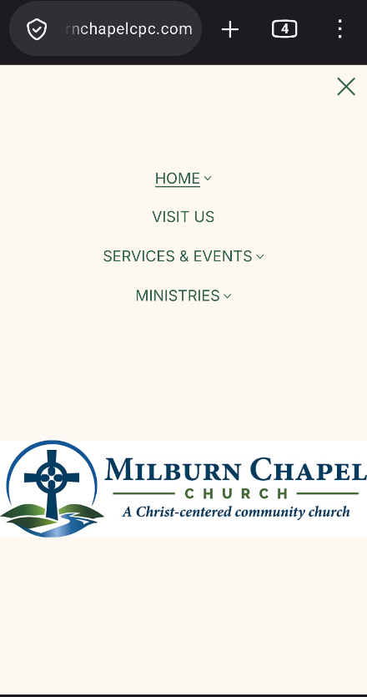
If you click on this icon with your finger or pen stylus, a detailed website menu will be displayed. (See image on your left).
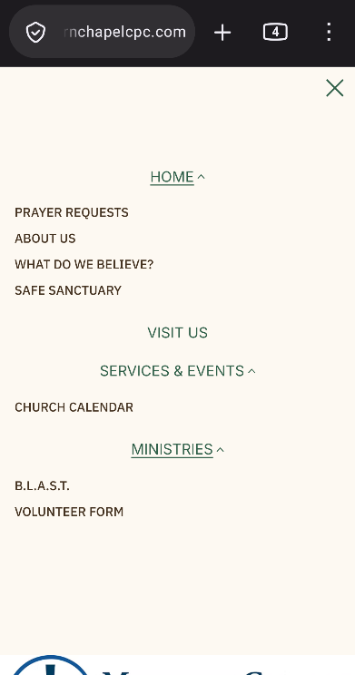
You will see menu headers (e.g., “Home”, “Visit Us”, “Services & Events”, and “Ministries”). You can click on these items, and a new web page will open. Some menu headers may have a to the right of the menu name. If you click on this “arrow”, a drop-down list of additional pages will be displayed for you to click on. If you wish to hide (collapse) these pages from the menu, just click on the icon. (See image on your right).
If you have any questions or comments regarding this website, please feel free to email us at milburnchapelcpcwebsite@gmail.com .

